**Connectivity to MongoDB in Cloud**

There are three ways for users to connect to MongoDB in the cloud.

# 1. Mongo Shell: MongoDB's command line interface for performing CRUD actions

* To connect to MongoDB in the cloud, users can select the "Connect" option.

* From the ‘Access your data through rules’ section, select ‘Shell’.

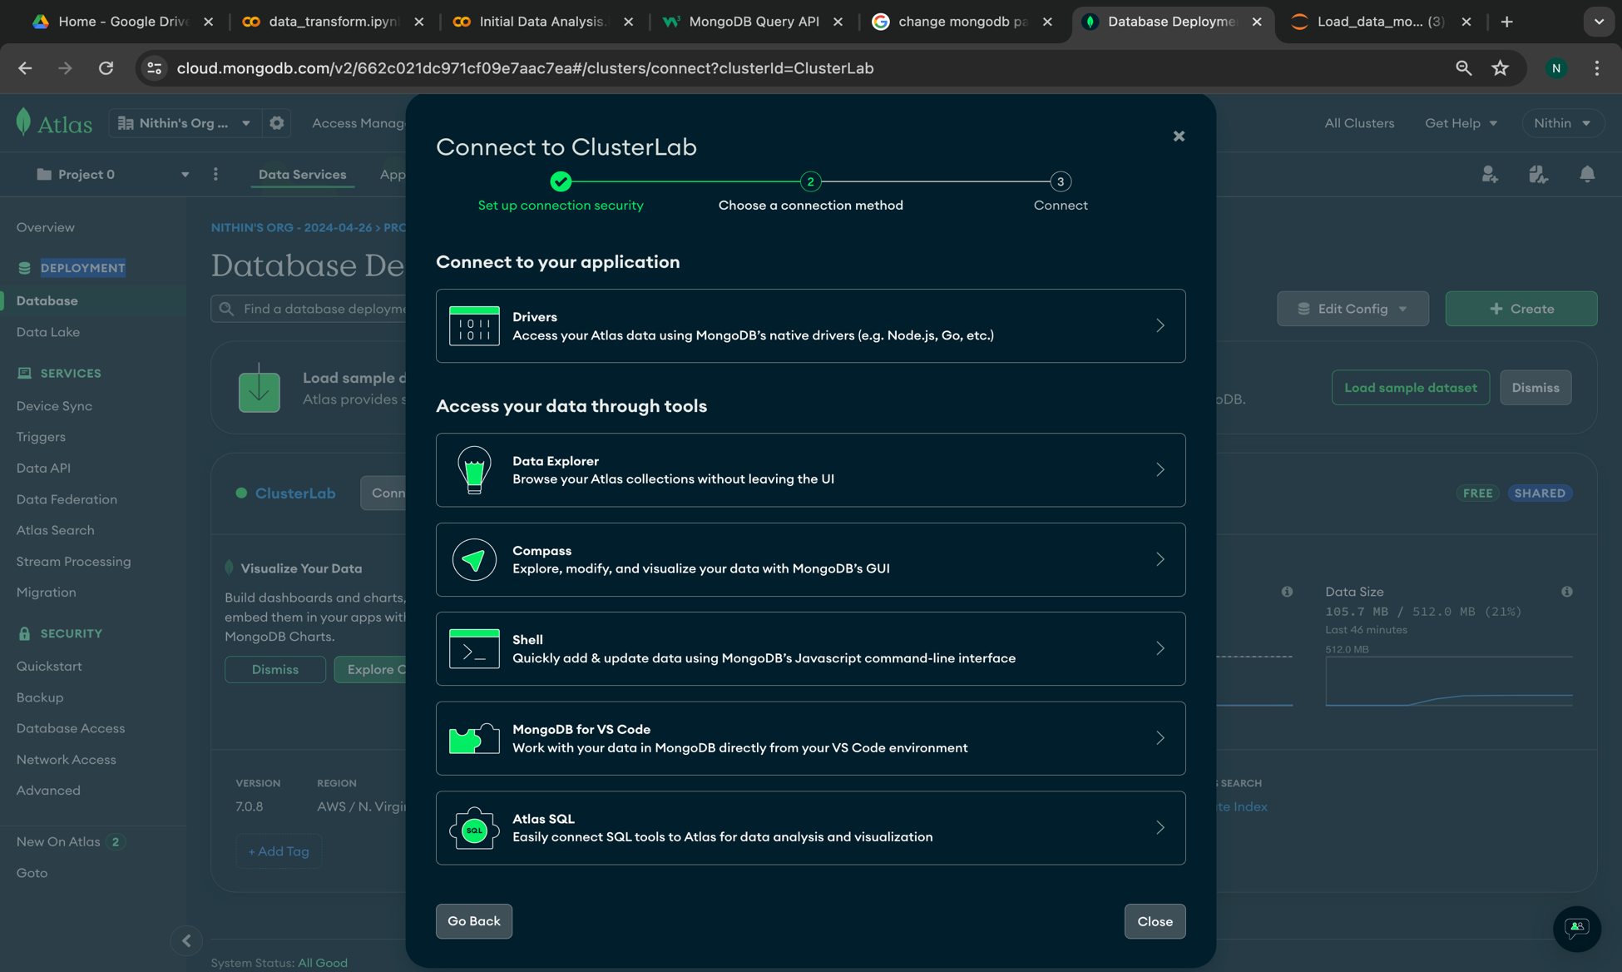

* Users can also download "mongosh" and add the "mongosh" path to the path variable.

After that, they can copy the connection string and paste it into the command prompt.

* Upon typing the correct password given during the user creation, the user will successfully connect to MongoDB in the cloud. Once connected, users can perform any CRUD operations.

2. Compass- Graphic User Interface to explore and perform operations.

* From the ‘Access your data through rules’ section, select ‘Compass’. .

* Download the Compass exe file to your system and then copy the connection string.

* Connection string: mongodb+srv://nithinkeshavamurthy:<password>@clusterlab.v4ntcje.mongodb.net/

(replace <password> with password created for the user)

* After installing the application on your system, open the application.

* Replace the URL field with the connection string that was copied from the MongoDB website, and then click on the "Connect" button.
* Upon successfully establishing a connection, you should be able to view the collections and documents stored within the cluster that you just connected to.

* Now that the user has successfully connected to the cluster using Compass, they can explore and perform any necessary operations within the application.

# 3. Cloud Connection

* Users can also establish a connection to MongoDB cloud by logging into their account. Once you have logged into your account, you can proceed to establish a connection.

* After logging into your MongoDB cloud account, select "Command Line Tools" in the cluster to access the data stored within the collections. From there, you can perform operations on the data and explore the contents of the collections.

